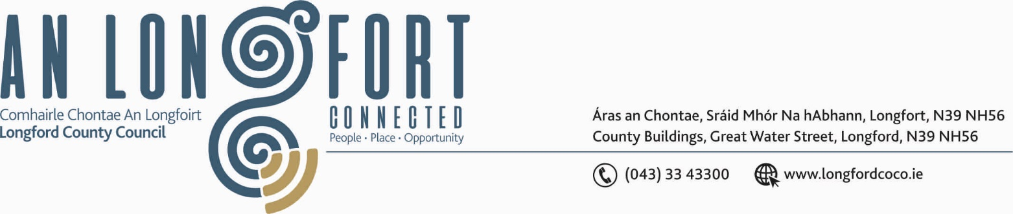

GRANARD MUNICIPAL DISTRICT

Please note meeting will be held via Microsoft Teams.

16th March 2021.

To: Each Member of Granard Municipal District.

Dear Member,

You are requested to attend Meeting of Granard Municipal District to be held
via Microsoft Teams on Tuesday, 23rd March 2021 at 3.30 p.m.
to transact business, as set out on the Agenda hereunder.

Yours sincerely,
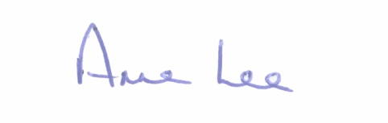

_______________
Anne Lee,
Meetings Administrator.

AGENDA

Prayer before meeting.

1. Confirmation of Minutes of Granard Municipal District Meeting held on the 26th January 2021 – copy enclosed.

2. Matters arising from Minutes.

3. Declaration of Interest by Members.

4. Management Report incorporating Area Engineer’s Progress Report
- enclosed.

5. Granard Public Art Features.

6. Consideration of applications for funding under the 2021 Community Grant
Support Scheme - list enclosed.

7. Special Projects Funding 2021.

8. Consideration of 2021 Schedule of Granard Municipal District Works – enclosed.

9. Walks and Trails in Granard MD – a coordinated approach.

10. Notices of Motions, submitted by Councillors, as listed hereunder –

Councillor Turlough Mc Govern
“I call on Longford County Council to negotiate with the Bank Of Ireland (Granard) Management to retain the ATM in the Town until such time that we can secure another operator to facilitate an ATM Machine for the People, the Businesses and Wider Community of the Granard Area”.
“I would like to call on Longford County Council's Regeneration Team for to upgrade the paths in Derrycassin Woods (re surfacing all the paths) and install dog fouling/litter bins at the entrance and at the picnic area”
Councillor Paraic Brady
“I call on Longford County Council and Regeneration team to look at providing car parking facilities at Cairn Hill as it is a huge success story that needs adequate parking”.

“I call on Longford County council to have a look at providing play area at the Dromard GAA grounds and adjacent to the crèche”.

Councillor Paraic Brady & Colin Dalton
“I call on Longford County Council and Regeneration team to look at providing a cycle path from the village of Ennybegs to Killoe national school as Killoe area development have put in a huge amount of work into this. Joint motion with Colin Dalton”.


